- Program ID : VH003MA1

- Display Layout
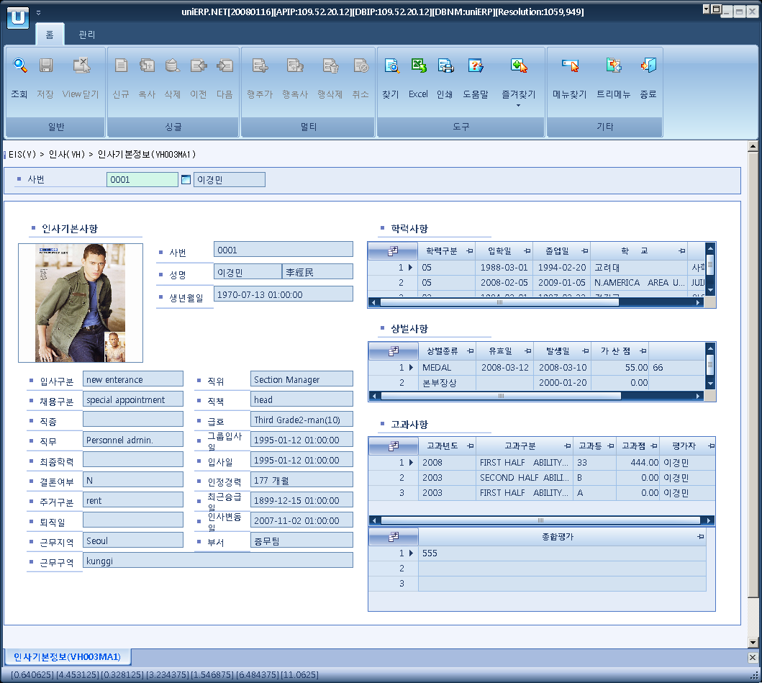

- Event flow
- Click Query button
- OnFncQuery -> DbQuery -> DataChange
- Display Unit combo change
- uniCombo1_ValueChanged -> DataChange

- SQL Statements
- Base information of employee
SELECT b.photo, a.emp_no, a.name, a.birt, a.hanja_name,
c.minor_nm, d.minor_nm, e.minor_nm, f.minor_nm, g.minor_nm,
a.marry_cd, h.minor_nm, a.retire_dt, i.minor_nm, j.minor_nm,
k.minor_nm, l.minor_nm, m.minor_nm, a.pay_grd2, a.group_entr_dt,
a.entr_dt, a.career_mm, a.resent_promote_dt, a.order_change_dt,
a.dept_nm
FROM haa010t a
LEFT JOIN haa070t b
ON b.emp_no = a.emp_no
LEFT JOIN b_minor c
ON c.minor_cd = a.entr_cd
AND c.major_cd = 'H0016'
LEFT JOIN b_minor d
ON d.minor_cd = a.app_cd
AND d.major_cd = 'H0017'
LEFT JOIN b_minor e
ON e.minor_cd = a.ocpt_type
AND e.major_cd = 'H0003'
LEFT JOIN b_minor f
ON f.minor_cd = a.func_cd
AND f.major_cd = 'H0004'
LEFT JOIN b_minor g
ON g.minor_cd = a.func_cd
AND g.major_cd = 'H0007'
LEFT JOIN b_minor h
ON h.minor_cd = a.house_cd
AND h.major_cd = 'H0015'
LEFT JOIN b_minor i
ON i.minor_cd = a.wk_area_cd
AND i.major_cd = 'H0036'
LEFT JOIN b_minor j
ON j.minor_cd = a.sect_cd
AND j.major_cd = 'H0035'
LEFT JOIN b_minor k
ON k.minor_cd = a.roll_pstn
AND k.major_cd = 'H0002'
LEFT JOIN b_minor l
ON l.minor_cd = a.role_cd
AND l.major_cd = 'H0026'
LEFT JOIN b_minor m
ON m.minor_cd = a.pay_grd1
AND m.major_cd = 'H0001'
WHERE a.EMP_NO = @strEmpNo

- Educational information of employee
SELECT HAA030T.SCH_SHIP, HAA030T.ADMI_DT, HAA030T.GRDUT_DT, HAA030T.SCHOOL_NM, HAA030T.MAJOR_NM
FROM HAA030T
WHERE HAA030T.EMP_NO = @strEmpNo
ORDER BY HAA030T.SCH_SHIP DESC

- Reward and punishment history of employee
SELECT HBA020T.PRZE_PERNISH_NM, HBA020T.END_DT, HBA020T.CRT_DT, HBA020T.ADD_POINT, HBA020T.CONT
FROM HBA020T
WHERE HBA020T.EMP_NO = @strEmpNo
ORDER BY HBA020T.END_DT DESC

- Valuation history
SELECT HBA040T.EVAL_YY, b_minor.minor_nm, HBA040T.VALUE_GRADE, HBA040T.VALUE_SCORE, HAA010T.NAME
FROM HBA040T, HAA010T, b_minor
WHERE HBA040T.EMP_NO = @strEmpNo
AND HBA040T.EMP_NO = HAA010T.EMP_NO
AND b_minor.major_cd = 'H0045'
AND b_minor.minor_cd = HBA040T.EVAL_TYPE
ORDER BY HBA040T.EVAL_YY DESC,HBA040T.EVAL_TYPE DESC

- remark
SELECT HBA040T.TOT_VALU
FROM HBA040T
WHERE HBA040T.EMP_NO = @strEmpNo
ORDER BY HBA040T.EVAL_YY DESC, HBA040T.EVAL_TYPE DESC

